# Website map

## The URL

[www.runforacause.vn](http://www.runforacause.vn)

## Site name

Running for a Cause

## English website

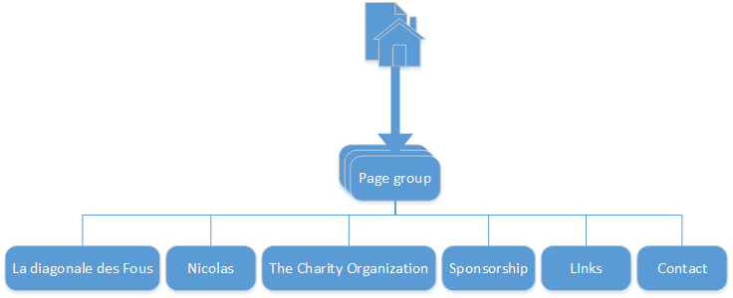

# Website design (fr+en)

## Color Scheme:

**Banderole:**

* Change orange to grey as below
* Text blue as logo of the grand raid
* OK for the home and flags but they look too small
* Remove the logo

|  |
| --- |
| **RUNNING “LE GRAND RAID” FOR A CAUSE** |

**Picture banderole:**

|  |
| --- |
|  |

**TEXT:**

* All orange and yellow text to become dark blue
* Same for the white text on the yellow, now can’t read it

**Timer:**

OK but

Below timer, but above the pages selection, we add the introduction as below:

**Introduction:**

**Donation Chart:**

* Mention (1Euro=1USD)
* For EURO-USD, only 2 number after the coma!!
* For VND, no coma at all only plain numbers

**List of donations:**

- Don’t mention the amount per person, only “Has made a donation” and the comments if any

**Contact me:**

Remove Freshstudio

Put my email: Nicolas.privet@gmail.com

## Logos and addresses

|  |  |
| --- | --- |
|  |  |
| **Fr/En: Le Grand Raid – La Diagonale des fous**  **Fr:** <http://www.grandraid-reunion.com>  **En:** <http://www.grandraid-reunion.com/?lang=en>  **Facebook:** <https://www.facebook.com/pages/Grand-Raid-Réunion-Officiel/571671339550394?ref=ts&fref=ts> | **Fr: Les Enfants du Dragon**  **En:** **The children of the Dragon**  **Fr:** <http://lesenfantsdudragon.com/>  **Facebook:** <https://www.facebook.com/groups/Enfantsdudragon> |
|  | FusionDrive:nprivet:Desktop:IMG_0522.jpg |
| **Fr/En: Ruby Soho**  **Adresse:** S52-1, Pham Van Nghi, Sky Garden 2, Phu My Hung, District 7, Ho Chi Minh City, Vietnam  **Facebook:** <https://www.facebook.com/groups/342286199158879/?ref=ts&fref=ts> | **Fr/En: Nicolas Privet**  **Facebook:** <https://www.facebook.com/privet.nicolas>  **Email:** Nicolas.privet@laposte.net |
|  |  |

## Pages design

# Page per page (eng)

## Home page

Welcome!

Introduction!

What is “La diagonale des fous”???

Read more

Photo gallery

Who is Nicolas??

………

Read more

Photo gallery

How Money will be raised? How can you support the project?

Read more

Who is the Charity “Les enfants du Dragon”

Read more

Who are the Sponsors?

Read more

Contact us

Read more

## La diagonale des fous

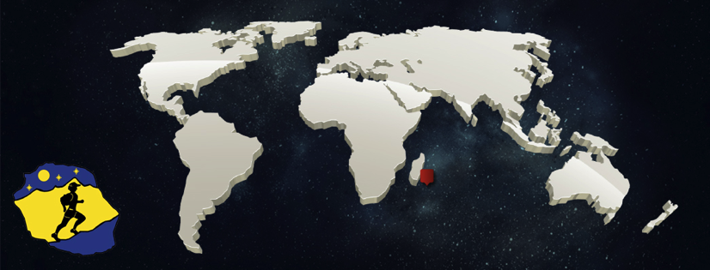

|  |  |
| --- | --- |
| **Name:** La Diagonale des Fous - (The Madmen's Diagonal)  **Since:** 1989  **Distance:** 163 Km  **Elevation:** 9’920 m  **When:** October 22nd to 25th 2015  **Where:** La Réunion Island  **Website:** [www.grandraid-reunion.com](http://www.grandraid-reunion.com/) | FusionDrive:nprivet:Desktop:Site_fous:ile-la-reunion.jpg |

The Grand Raid de la Réunion, also called La diagonale des fous (The Madmen's Diagonal) is a mountain [ultramarathon](http://en.wikipedia.org/wiki/Ultramarathon) race. The race takes annually place in October on [Réunion](http://en.wikipedia.org/wiki/R%C3%A9union) island, a French overseas department in the Indian Ocean, situated between Madagascar and Mauritius.

Lien goggle map

**Just imagine running a full mountain marathon! Challenging?**

**So**

**Just imagine running four full mountain marathons in a row! Completely crazy!**

And yet it is the feat the “diagonale des fous” finishers accomplish. When they are presented with the medal and the yellow tee-shirt emblazoned “I survived”, they have run, in a single stage, over 163km and climbed 9900m which is equivalent to 30 Eiffel Tower. It is reputed to be one of the 10th hardest race in the world

**And it is what Nicolas aspires to achieve!**

The Grand Raid is a fantastic physical challenge and those who dare it are half sportsmen, full madmen, indeed! From start to finish competitors climb 5 peaks culminating at about 2000m (the highest point being 2411m high!). They skirt the volcano, touch the sky on crest paths overlooking deep ravines, the cirque of Cilaos, they walk through Mafate and waddle ankle deep in mud in Kerveguen forest. The Grand Raid has become a myth: out of the initial 2500 or so, less than 70% make it to the finish.

The winner (professional athlete) completes the race in about 22 hours while the last finisher is allowed 64!

Official race website:

<http://www.grandraid-reunion.com/?lang=en>

Official race Facebook page:

<https://www.facebook.com/pages/Grand-Raid-Réunion-Officiel/571671339550394?ref=ts&fref=ts>

YouTube links:

<https://www.youtube.com/watch?v=XXVSsu6grnI>

<https://www.youtube.com/watch?v=z6Q7ohpeF7I>

## Nicolas

|  |  |
| --- | --- |
| FusionDrive:nprivet:Desktop:IMG_0522.jpg | FusionDrive:nprivet:Desktop:nico.jpg |

Nicolas is a 33 years old man, born in France, living and working in Vietnam since 2006.

His start in running

Nicolas started running very recently, less than 2 years ago, with his first race being a 10km in December 2013. One month later his first race, in January 2014, he was joining and achieving a 50km trail running race in Thailand.

His first 100km

One year later, after keeping training and joining few more races, in January 2015, Nicolas went back to Thailand and ran his first 100 km with a satisfying result, as ranked 29 on 191 participants. Having done this, Nicolas owned enough points to register for some thing crazy…

It is this day that the decision to join “La diagonale des fous” was taken! A single stage race of 163km for 9920 meters elevation. #Insane…

Nicolas & “La Reunion Island”

Nicolas knows well the place… He was there in 2005 for 5 weeks and when he was not drinking rhum and enjoying Zamal, he spent most of his time hiking around the 3 circus and the volcano with his friend Jojo! What do I remember from this experience: “Gorgeous landscape, fauna and flora, Nice people, Super hot weather, Very technical trails, Crazy elevation”

#RunForACause

To empower his new challenge, have an impact and also harden his motivation, Nicolas has decided to do not race only for himself, but to support a charity association, at each footstep he will make during the race… Nicolas has then contacted the French managed charity based in Vietnam, Les Enfants Du Dragon, which has shown great interest in being part of the adventure.

**Note that 100% of donated money will go directly to the Charity “Les Enfants du Dragon”**

Training

The training content ,….

The heat in Vietnam in which Nicolas is used to train will support him in achieving this race, But, …. , Ho Chi Minh Area is desperately flat, which is a major challenge for hill training. To compensate for it, Nicolas trains in high building stair cage (24 floors) and love his jumping rope!

Last few running races that Nicolas recently joined:

|  |  |  |  |  |
| --- | --- | --- | --- | --- |
| **Date** | **Race** | **Type** | **Dist. Km** | **Rank** |
| Jan 15 | The North Face Thailand 2015 | Trail running | 100  elev.2100 | 29/191 |
| Jan 15 | HCMC Half Marathon 2015 | Running | 21,1 | 113/576 |
| Dec 14 | The North Face Hong Kong 2014 | Trail running | 50  elev.3300 | 150/474 |
| Dec 14 | Hanoi Half Marathon 2014 | Running | 21,1 | 56/114 |

Competitions to come before “La diagonale des fous””

|  |  |  |  |  |
| --- | --- | --- | --- | --- |
| **Date** | **Race** | **Type** | **Dist. Km** | **Rank** |
| May 15 | Le Fruit Off-road Triathlon 2015 | Off-road triathlon | 51 |  |
| July 15 | Le Trail des Passerelles du Monteynard | Trail running | 35  elev.1800 |  |
| Sept 14 | Vietnam Mountain Marathon 2015 | Trail running | 70  elev.3000 |  |

Others sports events where Nicolas had fun, gained experience in managing pain… , and of course finished!

* Ta Lai Trophy 2015 & 2014: Quadriathlon in the Vietnamese Jungle ; Kayak, swimming, mountain Bike, off road running
* Dragon Dash 2015 HCMC
* Danang International Marathon 2014,…

Here, Nicolas will update here regularly on his training status, conditions and publish articles on his equipments, nutrition, …

* Link
* Link
* Link

## L’association

**Note that :**

**ALL donated money will go entirely and directly to the Charity “Les Enfants du Dragon”**

## Sponsor

**The Ruby Soho Saigon** !

Potentials

Thu sports, any others even small very welcome…!☺

## Contacts and links

## Gallery

|  |  |
| --- | --- |
| **NICOLAS** | |
| FusionDrive:nprivet:Pictures:Photos:Photos06_14:2014:ipad2014:IMG_0351.JPG | FusionDrive:nprivet:Pictures:Photos:Photos06_14:2014:September-december:photo 2.JPG |
|  |  |
| FusionDrive:nprivet:Pictures:Photos:Photos06_14:2015:dragon:IMG_2814.jpg | FusionDrive:nprivet:Desktop:Screen Shot 2015-04-07 at 14.10.03.png |
| FusionDrive:nprivet:Pictures:Photos:Photos06_14:2014:ipad2014:IMG_0546.JPG | FusionDrive:nprivet:Pictures:Photos:Photos06_14:2014:ipad2014:IMG_1348.JPG |
| FusionDrive:nprivet:Pictures:Photos:Photos06_14:2014:ipad2014:IMG_1331.JPG | FusionDrive:nprivet:Pictures:Photos:Photos06_14:2014:ipad2014:IMG_1206.JPG |
| FusionDrive:nprivet:Desktop:IMG_0522.jpg | FusionDrive:nprivet:Pictures:Photos:Photos06_14:2014:ipad2014:IMG_0717.JPG |
| FusionDrive:nprivet:Pictures:Photos:Photos06_14:2014:ipad2014:IMG_1361.JPG | FusionDrive:nprivet:Desktop:nico.jpg |

|  |  |
| --- | --- |
| **The Reunion Island - La diagonale des fous** | |
|  |  |
|  |  |
|  |  |
|  |  |
|  |  |
| FusionDrive:nprivet:Desktop:Site_fous:affiche-GrandRaid.jpg | FusionDrive:nprivet:Desktop:Site_fous:tshirt-grandraid1.jpg |
|  |  |